CA-26
2016 IE Strategy Memorandum

Updated on 4/25/16

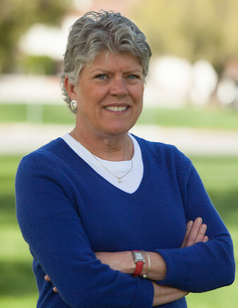
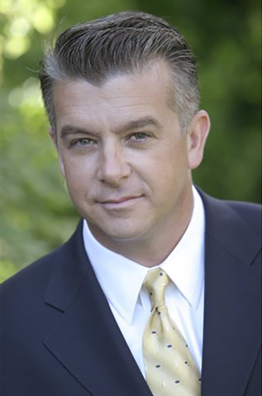

JULIA BROWNLEY RAFAEL DAGNESSES
CoH: $1,826,184.40 CoH: $99,342.38
Date: 4/15/16 Date: 4/15/16
Occupation: Congresswoman Occupation: Small Business Owner/Marine Corp (ret)

SECTION I: Race Overview
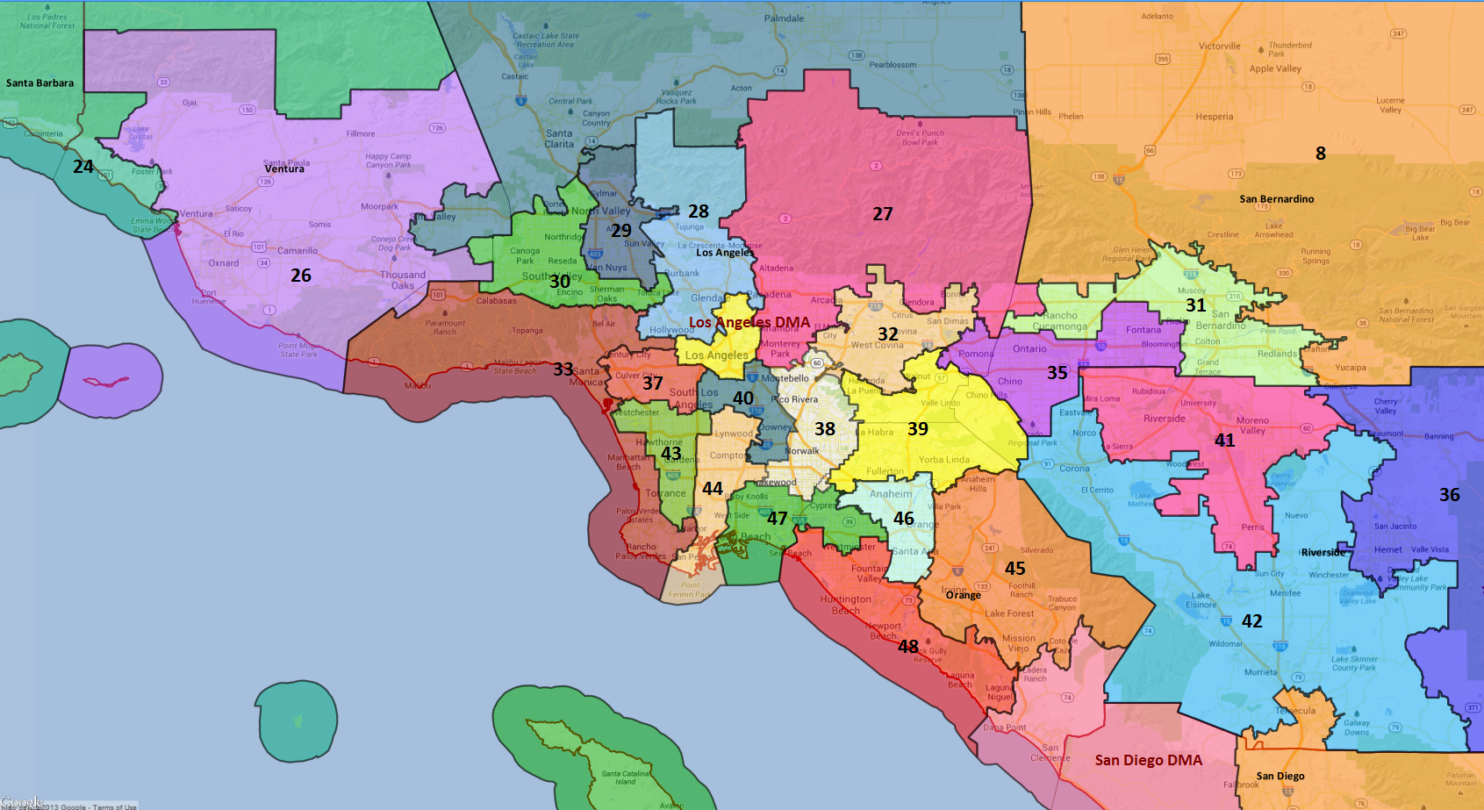

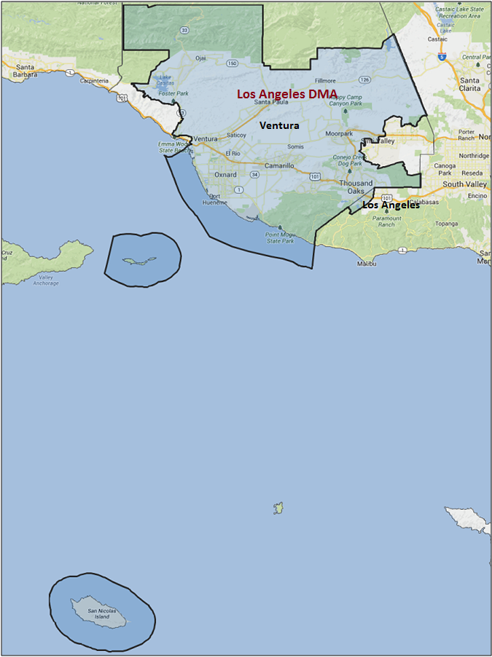

Media Market Costs

TV DMA | % of  CD | I.E.  35+ CPP | Cable CPP
LOS ANGELES | 100% | $1906 | $640
CA-26 TOTALS: | 100.0%
Radio Landscape
DMA | Universe | CPP
Oxnard/Ventura | 453,400 | $85

Digital Landscape
  - Persuasion universe size: 29,819
  - Audience extension (key demos): Hispanic
  - Weekly budget for full coverage: $10,915.40
  - Reach
    - YouTube - 335,929
    - Pandora - 236,733

Presidential Statistics
Cycle | Candidate | Party | Vote
2012 | Obama | DEM | 55.2%
2012 | Romney | REP | 44.8%
2008 | Obama | DEM | 57.7%
2008 | McCain | REP | 42.3%

Congressional Statistics
Cycle | W/L | Candidate | Party | Vote
2014 | W | BROWNLEY | DEM | 51.3%
2014 | L | GORELL | REP | 48.7%
2012 | W | BROWNLEY | DEM | 52.7%
2012 | L | STRICKLAND | REP | 47.3%

NCEC Data
Dem Performance: 53.5%
BVAP: 2.3%
Hispanic: 29.6%
Asian: 7.2%
Total Minority: 54.1%

Critical Dates
Filing Date: June 7th 2016
Primary Date: March 25th 2016

Summary of 2014 Cycle Spending by Outside Groups
TV Competitive Summary – Los Angeles
Campaign/Group | Total GRPs | Total Dollars
Julia Brownley/DCCC | 755 | $906,375
Jeff Gorell/NRCC | 179 | $100,002
DCCC | 2,200 | $1,305,951
American Future Fund | 852 | $834,324
Good Guys vs Bad Guys | Total GRPs | Total Dollars
Good Guys | 2,955 | $2,212,326
Bad Guys | 1,031 | $934,326
TV Competitive Summary – Santa Barbara
Campaign/Group | Total GRPs | Total Dollars
Julia Brownley/DCCC | 703 | $86,500
Good Guys vs Bad Guys | Total GRPs | Total Dollars
Good Guys | 703 | $86,500
Bad Guys | N/A | N/A

Radio Competitive Summary – Oxnard - Ventura
Campaign/Group | Total GRPs | Total Dollars
DCCC | 1,885 | $69,070
Good Guys vs Bad Guys | Total GRPs | Total Dollars
Good Guys | 1,885 | $69,070
Bad Guys | N/A | N/A

Summary of 2012 Cycle Spending by Outside Groups

TV Competitive Summary -- Los Angeles
Campaign/Group | GRPs | Total Dollars
House Majority PAC | 788 | $523,832
SEIU | 360 | $211,000
American Future Fund | 429 | $499,995
Chamber of Commerce | 111 | $437,340
Good Guys v Bad Guys | GRPs | Total Dollars
Good Guys | 1,148 | $734,832
Bad Guys | 540 | $937,335
Pre-Election Day Voting

Type of  “Early Voting” | Start Date  End Date | Percent of  Vote Cast Using this Method | Brief Description  (where/how  do people vote) | Timeframe (when does the majority of voting happen)
Early Vote In Person | County by County |  | Return in person—to your county elections office or any polling place in your county before 8:00 p.m. on Nov. 8th
Absentee Ballot/In person Absentee
Vote By Mail | Oct. 10th – Nov 1

SECTION II: DISTRICT OVERVIEW

- District Overview and Data

  - Political Landscape
- In 2016, Democratic Congresswoman Julia Brownley is running for her third term against Cuban-American veteran and small business owner Rafael Dagnesses.
- Per a September 2015 poll conducted by the DCCC, likely general election voters have a favorable view of Brownley (33% fav to 21% unfav with 46% undecided), but an even percentage of voters would vote to re-elect Brownley and would vote for someone else (34% reelect, 34% vote for someone else, 32% unsure). In the generic ballot, the generic Democrat had a 7 point lead over the generic Republican (42% to 35%, 23% undecided).
- A major rule change that will impact the 2016 race is Senate Bill 29, which rules boards of elections must count absentee ballots that arrive up to three days after the election that are postmarked on or before Election Day, will take effect this cycle. Previously, board of elections only counted ballots counties received by Election Day. The new DMV Motor Voter Law will not be in effect for the 2016 cycle.
- It is now much easier for a ballot initiative to qualify for the ballot, and we therefore expect a very high number of ballot measures to appear in 2016. Ballot initiatives that may impact the electorate include:
  - A “Fight for $15” minimum wage increase that is being sponsored by SEIU
  - A possible initiative that will legalize the recreational use of marijuana
  - A ban of the possession and sale of large ammunition clips
  - Proposition 30 extensions that would continue higher income tax for the wealthiest Californians
  - School Funding and Budget Stability Act that would extend Prop 30’s income tax increases through 2030 and fund K-14 education
  - The “Invest in California’s Children Act,” which would impose higher rates on individual tax filers earning more than $1 million per year

  - District Demographics
- Running along the central coast and inland, CA-26 encompasses most of Ventura County and a portion of Los Angeles County. The district’s major cities include Oxnard, Ventura, Thousand Oaks, Camarillo, Santa Paula and Westlake Village.
- The expensive Los Angeles media market, which has an average campaign CPP of $1,589, covers the entire district.
- A true swing district in midterm years, CA-26 has a more favorable voting population in presidential years. CA-26 is younger (22.6% aged 18-35 compared to 11.6% aged 65+) and over a quarter Hispanic (29.6% of the Citizen Voting Age Population) with an average household income 20% higher than the state average.
- The district is well-known for its beaches, and tourism drives the economy, in addition to international trade, agriculture, defense industries. Oxnard serves as a key manufacturer in the Los Angeles area and the Port of Hueneme is the only deep-harbor commercial port between Los Angeles and San Francisco. The district is also home to the Oxnard Oil Field, the West Montalvo Oil Field, and the Tenby Oxnard Refinery.
- Voters in California register with a party or “decline to state.” Unless otherwise noted, party references in the document refer to party registration.

District Demographics

- Cook Partisan Voting Index: D+4
- Urban Population: 42.7%
- Rural Population: 18%
- Suburb Population: 39.3%
- Median Income: $74,758
- Poverty Status: 7.2%
- Military Veterans: 8.6%
- Race/Ethnic Origin: 60.9% White; 2.3% Black; 7.2% Asian; 29.6 Hispanic

  - Electoral Context
- President Obama carried the district in both 2012 (55.2% of the two-way vote) and 2008 (57.7% of the two-way vote). Support for the President in 2012 surpassed the Democratic performance average (DPI) in Ventura County by 4.7 points and in Los Angeles County by 1.2 points.
- In 2012, Rep. Brownley won this swing district with 52.7% in a close race against former State Senator Tony Strickland. Despite being outraised and outspent by Strickland, Brownley performed within 2.5 points of the President and 2 points ahead of the average Democratic performance.
- In 2014, Republican Assemblyman Jeff Gorell challenged Brownley. Brownley looked vulnerable early on and polls remained within the margin of error throughout the summer and fall. The Brownley campaign attacked Assemblyman Gorell for his background as a lobbyist, but despite her massive resource advantage (2.5 to 1) she was never able to fully damage Gorell’s standing amongst the electorate. Brownley led Gorrell on Election Night by 530 votes and eventually pulled out a one point victory (4,523 votes), thanks in part to late absentee ballots.
- CA-26 has traditionally comprised a small portion of the top-of-ticket vote share. Pending the outcome of the June 2015 primary, Senate candidates may have a presence in CA-26. The sizable Hispanic/Latino population would likely be a shared target for both Loretta Sanchez and our congressional campaign. Again, per a DCCC poll conducted in September 2015, voters in the district have an unfavorable view of Hilary Clinton (36% fav, 47% unfav and 17% did not rate).
- The 2016 DPI is 51.4%, a 3.6 point increase from the 2014 DPI of 50.5% and a 3.4% increase over the 2012 DPI of 50.7%.

  - Press Presence
- The expensive Los Angeles media market, which has an average campaign CPP of $1,589, covers the entire district.
- CA-26 will be a target for turnout votes for the statewide senate candidate. The market is already one of the most expensive in the country, we will complete with the statewide on price.
- The Ventura County Star will cover this race closely, and has not been kind to Democrats

Other papers:

- Acorn: suburban journals in Camanillo, Moorpark, Simi Valley, and Twin Oaks
- LA Times publishes a Ventura County Edition
- Onji Valley News
- Santa Pamela News
- Ventura County Reporter
- KEYT TV – Santa Barbara based TV that will cover northern half of district

SECTION III: MESSAGE

Message Box

Democrat Self Frame  Brownley has dedicated her life to improving our schools, fixing the broken healthcare system, supporting a women’s right to choose, and has lead the effort to clean up toxic waste from the Santa Susana Field Laboratory. | Republican Self Frame  Rafael believes that government serves its citizens best when it is limited and adheres to constitutional principles. When citizens are overly taxed and job creators are unfairly burdened by regulations, innovation is stifled and hard-working Americans lose jobs.  When businesses would rather relocate abroad that deal with our job-killing regulations, it's a clear sign government has gone from helping citizens to standing in their way.  In Congress, Rafael will work to return government to its Constitutional role, stop the expansion of over-reaching bureaucracy, and eliminate duplicitous and wasteful spending.
Likeliest Attacks on Democrat  Obama/Pelosi Democrat, voted with them XX percent of the time, supports higher taxes, defends Obamacare, not doing anything to reduce the deficit.  Voted for the Iran deal.  Congressional perks, taxpayer salary. | Best Attacks on Republican  Dagnesses is not a serious candidate. Republicans were not able to recruit in CA-26.  Dagnesses has questionable judgment that has gotten him and his company in legal trouble on a number of occasions.  Dagnesses is out-of-step with the 26th District, with calls to eliminate the Department of Education and opposition to equal pay legislation.  Dagnesses is a carpetbagger, having moved to the 26th District the same month he announced his candidacy for the District’s Congressional seat in 2014.

- Julia Brownley

- Short Biography
Brownley grew up in Virginia in a Republican family. Brownley received a bachelor's degree in political science from Mount Vernon College for Women in 1975 and a master's degree in business administration from American University in 1979.
Brownley served on the Santa Monica-Malibu Unified School District Board of Education from 1994-2006. During her time on the school board, she served three terms as president
In 2006, she ran for the California State Assembly in California's 41st Assembly District. Brownley won a five-way Democratic primary with 35% of the vote.Brownley won the general election with 62% of the vote.In 2008, she won re-election to a second term with 66% of the vote. In 2010, she won re-election to a third term with 59% of the vote. Brownley was term-limited in 2012, having served the maximum of three terms in the Assembly permitted under California law

- Self-Frame
Brownley has dedicated her life to improving our schools, fixing the broken healthcare system, supporting a women’s right to choose, and has lead the effort to clean up toxic waste from the Santa Susana Field Laboratory.

- Likely Attacks
Obama/Pelosi Democrat, voted with them XX percent of the time, supports higher taxes, defends Obamacare, not doing anything to reduce the deficit.
Voted for the Iran deal.
Congressional perks, taxpayer salary.

- Assessment of Democratic Fundraising
DEMOCRAT | Q1 2015 | Q2 2015 | Q3 2015 | Q4 2015 | Q1 2016
Goal | N/A | $400,000 | $425,000 | $400,000 | $475,000
Actual Raised | $359,565 | $411,351 | $425,482 | $377,545 | $457,229

- Strengths and Weaknesses of Campaign
- Rep. Brownley was a consistent liberal vote as a State Senator, but has forged and maintained a more-moderate voting record as a Member of Congress and has maintained independent messaging throughout her reelection campaigns. While Rep. Brownley has stayed to the left on such issues as choice and the environment, she has moved to the center on fiscal issues and matters of National Security. This has engendered some distrust among local Democratic activists and some frustration from National Democratic leadership, but polling has showed that it’s vital she maintains her independence and moderate stance on these issues to not alienate her swing vote.
- Rep. Brownley is not very comfortable in large event settings, and therefore has historically had sub-par event programs -- impacting her press operation, official district presence, and finance plan.
- The 2016 environment should include several factors that could drive Democratic women to the polls, which would benefit Rep. Brownley given her immense and consistent popularity with that demographic group. California will feature an open Senate race, which will most-likely include at least one female Democrat in the general election, and a Presidential contest that may as well

- Rafael Dagnesses

- Short Biography
Born in Castro's Communist Cuba, Rafael Dagnesses and his family were able to escape to the United States as impoverished refugees.

Though he grew up in one of LA's poorest areas, he learned that by hard work, sacrifice and taking advantage of the freedoms offered by this great country, he could achieve the American Dream.

A Marine Corps Veteran and former law enforcement officer, Rafael is now a small business owner. He lives in the Santa Rosa Valley with his wife, Natalie, and two young sons.

- Self-Frame
Rafael believes that government serves its citizens best when it is limited and adheres to constitutional principles. When citizens are overly taxed and job creators are unfairly burdened by regulations, innovation is stifled and hard-working Americans lose jobs.
When businesses would rather relocate abroad that deal with our job-killing regulations, it's a clear sign government has gone from helping citizens to standing in their way.

In Congress, Rafael will work to return government to its Constitutional role, stop the expansion of over-reaching bureaucracy, and eliminate duplicitous and wasteful spending.

- Best Attacks

Republican Candidate | Ryan Budget(s) – (Include if its Votes or Statement) | Privatize Social Security | Defund Planned Parenthood | Anti-Choice Position
Rafael Dagnesses

CA-26 Research

Julia Brownley (Democratic Incumbent) Vulnerabilities

Julia Brownley was first elected to Congress in 2012. Prior to that she served in the State Assembly from 2006 to 2012 and was president of the Santa Monica-Malibu School Board. Brownley currently sits on the Veterans’ Affairs and Transportation Committees. She also has a strong record on environmental and women’s health issues. Brownley has been active on veteran affairs issues, particularly focusing on the VA clinics in the district and challenges that female veteran’s face.

Top Vulnerabilities
- Last cycle, NRCC attacked her for taking money from unions and voting against a bill to prevent people from fraudulently receiving subsidies for Obamacare plans
- Used to live in Santa Monica, not Ventura County so was attacked her for being a carpetbagger

Rafael Dagnesses (Republican Challenger) Vulnerabilities

- Appears to have supported Jeb Bush in the presidential
- Criticized Brownley for receiving contributions from Planned Parenthood during the hearings in fall of 2015—issue of choice and reproductive rights was a strong factor last cycle
- Opposed all “amnesty” for undocumented immigrants and supported building a wall along southern border
- Said “Leftists” are bringing Islam into society and supported monitoring mosques
- Supported eliminating IRS and Department of Education
- Wanted to fully repeal ACA and refused to fix it
- Had more than $98,000 in liens filed against him, including one IRS lien for almost $96,000
- Initially refused to acknowledge paternity of his first child
- Not a strong fundraiser

SECTION V: Appendix

- 2016 Campaign Side Consulting Team
Media: Dixon Davis Media Group
Mail: SG&A Campaigns - lead: Barkan
Polling: Tulchin Research - lead: Tulchin
Online/Digital: Mothership
Self-research: VR research

- Summary of Past Races and Important Differences for 2016
Recent Elections
- President Obama carried the district in both 2012 (55.2% of the two-way vote) and 2008 (57.7% of the two-way vote). Support for the President in 2012 surpassed the Democratic performance average (DPI) in Ventura County by 4.7 points and in Los Angeles County by 1.2 points.
- In 2012, Rep. Brownley won this swing district with 52.7% in a close race against former State Senator Tony Strickland. Despite being outraised and outspent by Strickland, Brownley performed within 2.5 points of the President and 2 points ahead of the average Democratic performance.
- Republican Assemblyman Jeff Gorell challenged Brownley in 2014. Brownley looked vulnerable early on and polls remained within the margin of error throughout the summer and fall. The Brownley campaign attacked Assemblyman Gorell for his background as a lobbyist, but despite her massive resource advantage (2.5 to 1) she was never able to fully damage Gorell’s standing amongst the electorate. Brownley led Gorrell on Election Night by 530 votes and eventually pulled out a one point victory (4,523 votes), thanks in part to late absentee ballots.
- The 2016 DPI is 51.4%, a 3.6 point increase from the 2014 DPI of 50.5% and a 3.4% increase over the 2012 DPI of 50.7%.

As expected, this race remained competitive throughout the campaign and required significant resources to win. Our message synched up with the campaign’s message, which was vital to drive the narrative in such an expensive media market. Running an incumbent with high name recognition was also an advantage. With the right message to appeal to the moderate voters in the district, and with high enough turnout in the Democratic cities (particularly Oxnard), CA-26 is a district Democrats can retain in future years. Brownley will likely need to remain vigilant in raising resources, and should be wary of a Gorell rematch in 2016.

Role of the I.E.
Redistricting allowed Brownley to narrowly defeat her opponent in 2012 in a district that had previously been a safe Republican seat. CA-26 was expected to be a competitive race from the beginning of the 2014 cycle, and the DCCC IE was prepared to make a substantial investment to protect the incumbent. We conducted a benchmark poll in mid-August, which showed the race in a dead heat, and a tracking poll at the beginning of October, by which time Brownley had opened up an 8-point lead. Still, with significant investments from Republican groups, it was necessary for the DCCC IE to spend heavily in this district. We ran 3 television spots, 3 Spanish-language radio spots, as well as persuasion and turnout digital products. Ultimately, low Republican turnout and Brownley’s strong showing in Oxnard kept this district in the Democratic column. Due to the IE’s efforts, Gorell’s unfavorable rating increased by 25%.

Summary: The 2014 DCCC IE Program aired 3 television spots in the Los Angeles (Cable Only) Media Market with a total of 2,200 GRPs. We utilized tracking footage in the second and third ads.

Ads run by DCCC in CA-26

- Spot 1 – D3C14-CA26-T01 “Strategies” // Los Angeles (731 GRPs): Hits Gorell for being a lobbyist in the pockets of special interests, allowing insurance companies to charge women more and deny coverage.

- Spot 2 – D3C14-CA26-T02 “High Life” // Los Angeles (729 GRPs): Hits Gorell for living the high life as a lobbyist and legislator at taxpayers’ expense.

- Spot 3 – D3C14-CA26-T03 “Strut” // Los Angeles (740 GRPs): Hits Gorell for being a lobbyist for special interests, allowing insurance companies to charge women more and deny coverage for pre-existing conditions, mammograms, and birth control.

- 2016 Targets
- Using the previous presidential election as a guide, official Secretary of State records from 2012 indicate a turnout rate of 76.3% of registrants (273,647 votes cast).
- Applying the 2012 turnout rate forward to the current electorate as defined by the Secretary of State, we can expect to see 276,436 voters, or 76.3% of the electorate, cast ballots in the 2016 General Election.
- As a result, a successful campaign will need 143,747 raw votes to reach a 52% support goal. A one-point shift in support equates to 2,764 raw votes.
- According to state records, registration has increased by about 3,750 individuals. Democratic share has increased by less than a point, while Republican share has decreased by 2.4 points and DTS registration has increased by 1.5 points since 2012. Democrats now have an 8 point registration advantage over Republicans, an increase of roughly 3 points since 2012. The projected 2016 voting population will be 1.6% less White and 0.4% more Hispanic/ Latino than 2014. Additionally, young people aged 18-29 will comprise 2.4% more of the vote share than last cycle.
- Ballot roll off was -3.5% in 2012. Moreover, a clear ticket splitting pattern emerged between the Presidential and Congressional contests. Brownley underperformed Obama and 5.9% of Obama voters did not vote for Brownley, while Strickland was more popular than Romney with 4.3% more voters voting for Strickland than Romney.
- The bulk of the Democratic base resides in the cities of Ventura (the county seat) and Oxnard, while voters in Ojai and Port Hueneme are supportive, but comprise a relatively small share of the Democratic vote (5% and 3% of the 2012 Congressional Democratic support, respectively). Our persuasion targets are densest in Port Hueneme and near Point Mugu. Our turnout targets are located throughout the district, but are densest in Oxnard, Port Hueneme and outside Thousand Oaks. Republicans won Thousand Oaks, the district’s third largest city, by at 10 points both of the last two cycles, and Camarillo, the fourth largest city, by an average of 15 points.

DEMOCRATS START THIS RACE NARROWLY AHEAD OF REPUBLICANS BUT SHY OF THE 52% VOTE GOAL BY 1,190 VOTES (51.5% TWO-WAY SUPPORT). VICTORY DEPENDS ON THE FOLLOWING:
- CONSOLIDATE DEMOCRATS TO 93.0% SUPPORT AND WIN DTS/ INDEPENDENT VOTERS
- BUILD SUPPORT FROM WOMEN BACK UP TO THE 56.0% HISTORIC HIGH
- GROW THE HISPANIC/LATINO VOTE SHARE BY INCREASING HISPANIC/LATINO TURNOUT TO 66%, DEMOCRATIC HISPANIC/LATINO TURNOUT TO 70.4% AND DTS HISPANIC/LATINO TURNOUT TO 50.4%
- INCREASE YOUTH TURNOUT TO 67%
- INCREASE TURNOUT IN OXNARD TO 79.5%
- WIN 52.8% OF VOTE-BY-MAIL BALLOTS

